Akhilanand Sirra (002197798)

**Program Structures & Algorithms**

**Fall 2021**

**Assignment No. 5**

**Task**

* Implement a parallel sorting algorithm such that each partition of the array is sorted in parallel. You will consider two different schemes for deciding whether to sort in parallel.
* (Part 1) A cutoff (defaults to, say, 1000) which you will update according to the first argument in the command line when running. It's your job to experiment and come up with a good value for this cutoff. If there are fewer elements to sort than the cutoff, then you should use the system sort instead.
* (Part 2) Recursion depth or the number of available threads. Using this determination, you might decide on an ideal number (*t*) of separate threads (stick to powers of 2) and arrange for that number of partitions to be parallelized (by preventing recursion after the depth of *lg t* is reached).
* (Part 3) Implement a main program to run the following benchmarks: measure the running times of this sort, using four different initial array ordering situations: random, ordered, partially-ordered and reverse-ordered.
* Show the results of your experiments and draws a conclusion (or more) about the efficacy of this method of parallelizing sort.
* Experiments should involve sorting arrays of sufficient size for the parallel sort to make a difference. You should run with many different array sizes (they must be sufficiently large to make parallel sorting worthwhile, obviously) and different cut-off schemes.

**Relationship Conclusion:**

After running experiments with different cutoff values and the number of threads for different array sizes, We can conclude that four threads are the optimal choice as the algorithm's performance does not increase significantly beyond four.

The lowest performance is achieved when the cutoff value is 25% of the array size.

For recursion depth $(d)$ and number of threads available $\left(t\right):$

$$t=2^{d}$$

Maximum depth possible:

$$lg⁡\left(\frac{array size}{cutoff}\right)$$

Any depth more significant than the max depth is not feasible as the partitioned arrays hit the cutoff and turned into a system sort.

**Evidence to support the conclusion:**

Array Size = 50000

|  |  |
| --- | --- |
| Thread = 2 |  |
| **Cutoff** | **Runtime** |
| 5000 | 71.2 |
| 10000 | 51.6 |
| 15000 | 28.8 |
| 20000 | 21.6 |
| 25000 | 20.6 |
| 30000 | 19.5 |
| 35000 | 24 |
| 40000 | 20.1 |
| 45000 | 20.5 |
| 50000 | 20 |
| Thread=4 |  |
| **Cutoff** | **Runtime** |
| 5000 | 22.2 |
| 10000 | 17.4 |
| 15000 | 16.9 |
| 20000 | 16.1 |
| 25000 | 17.1 |
| 30000 | 18.8 |
| 35000 | 18.1 |
| 40000 | 18.1 |
| 45000 | 18.6 |
| 50000 | 17.2 |
| Thread=8 |  |
| **Cutoff** | **Runtime** |
| 5000 | 22.7 |
| 10000 | 17 |
| 15000 | 16.5 |
| 20000 | 16.1 |
| 25000 | 16.7 |
| 30000 | 19.5 |
| 35000 | 18.5 |
| 40000 | 15.7 |
| 45000 | 16.3 |
| 50000 | 15.5 |
| Thread=16 |  |
| **Cutoff** | **Runtime** |
| 5000 | 19.7 |
| 10000 | 15.4 |
| 15000 | 16.3 |
| 20000 | 17.7 |
| 25000 | 18.6 |
| 30000 | 17.1 |
| 35000 | 17.2 |
| 40000 | 15.7 |
| 45000 | 16.3 |
| 50000 | 15.8 |
| Thread=32 |  |
| **Cutoff** | **Runtime** |
| 5000 | 20.2 |
| 10000 | 15.5 |
| 15000 | 19.7 |
| 20000 | 21.2 |
| 25000 | 25.4 |
| 30000 | 23.6 |
| 35000 | 16.8 |
| 40000 | 18.1 |
| 45000 | 17 |
| 50000 | 19.6 |

Array Size = 100000

|  |  |
| --- | --- |
| Thread=2 |  |
| **Cutoff** | **Runtime** |
| 5000 | 85.4 |
| 10000 | 68.6 |
| 15000 | 41.3 |
| 20000 | 40.6 |
| 25000 | 38.5 |
| 30000 | 45.8 |
| 35000 | 48.1 |
| 40000 | 41.4 |
| 45000 | 37.3 |
| 50000 | 36.3 |
| Thread=4 |  |
| **Cutoff** | **Runtime** |
| 5000 | 60 |
| 10000 | 46 |
| 15000 | 61.5 |
| 20000 | 50.3 |
| 25000 | 47.4 |
| 30000 | 47 |
| 35000 | 44.9 |
| 40000 | 49.8 |
| 45000 | 50.7 |
| 50000 | 48.8 |
| Thread=8 |  |
| **Cutoff** | **Runtime** |
| 5000 | 58.6 |
| 10000 | 43.4 |
| 15000 | 47.9 |
| 20000 | 50.3 |
| 25000 | 65.6 |
| 30000 | 60.2 |
| 35000 | 50.4 |
| 40000 | 57.4 |
| 45000 | 38.9 |
| 50000 | 43.6 |
| Thread=16 |  |
| **Cutoff** | **Runtime** |
| 5000 | 52.4 |
| 10000 | 38 |
| 15000 | 38.4 |
| 20000 | 37.1 |
| 25000 | 40.4 |
| 30000 | 38.2 |
| 35000 | 41.7 |
| 40000 | 35.5 |
| 45000 | 36.3 |
| 50000 | 39.2 |
| Thread=32 |  |
| **Cutoff** | **Runtime** |
| 5000 | 41.7 |
| 10000 | 38.8 |
| 15000 | 38.9 |
| 20000 | 44.4 |
| 25000 | 43.2 |
| 30000 | 41.7 |
| 35000 | 40.3 |
| 40000 | 36.8 |
| 45000 | 40 |
| 50000 | 35.7 |

Array Size = 200000

|  |  |
| --- | --- |
| Thread=2 |  |
| **Cutoff** | **Runtime** |
| 5000 | 170.8 |
| 10000 | 155.1 |
| 15000 | 92.8 |
| 20000 | 88.5 |
| 25000 | 92.9 |
| 30000 | 96.2 |
| 35000 | 93.1 |
| 40000 | 94.2 |
| 45000 | 91.1 |
| 50000 | 96.5 |
| Thread=4 |  |
| **Cutoff** | **Runtime** |
| 5000 | 106.5 |
| 10000 | 85.1 |
| 15000 | 93.6 |
| 20000 | 93.6 |
| 25000 | 100.4 |
| 30000 | 97 |
| 35000 | 106.7 |
| 40000 | 100.7 |
| 45000 | 101.2 |
| 50000 | 93.7 |
| Thread=8 |  |
| **Cutoff** | **Runtime** |
| 5000 | 102.9 |
| 10000 | 80.2 |
| 15000 | 81.4 |
| 20000 | 80.7 |
| 25000 | 76.7 |
| 30000 | 81.1 |
| 35000 | 71.1 |
| 40000 | 75.8 |
| 45000 | 76.8 |
| 50000 | 75.9 |
| Thread=16 |  |
| **Cutoff** | **Runtime** |
| 5000 | 93.2 |
| 10000 | 80.4 |
| 15000 | 84.1 |
| 20000 | 80.5 |
| 25000 | 83.6 |
| 30000 | 80.1 |
| 35000 | 76.4 |
| 40000 | 76.4 |
| 45000 | 79 |
| 50000 | 71.1 |
| Thread=32 |  |
| **Cutoff** | **Runtime** |
| 5000 | 88.3 |
| 10000 | 78.2 |
| 15000 | 78.3 |
| 20000 | 79.1 |
| 25000 | 87.4 |
| 30000 | 80.8 |
| 35000 | 70.6 |
| 40000 | 75.2 |
| 45000 | 81.8 |
| 50000 | 76.6 |

**Console Output:**

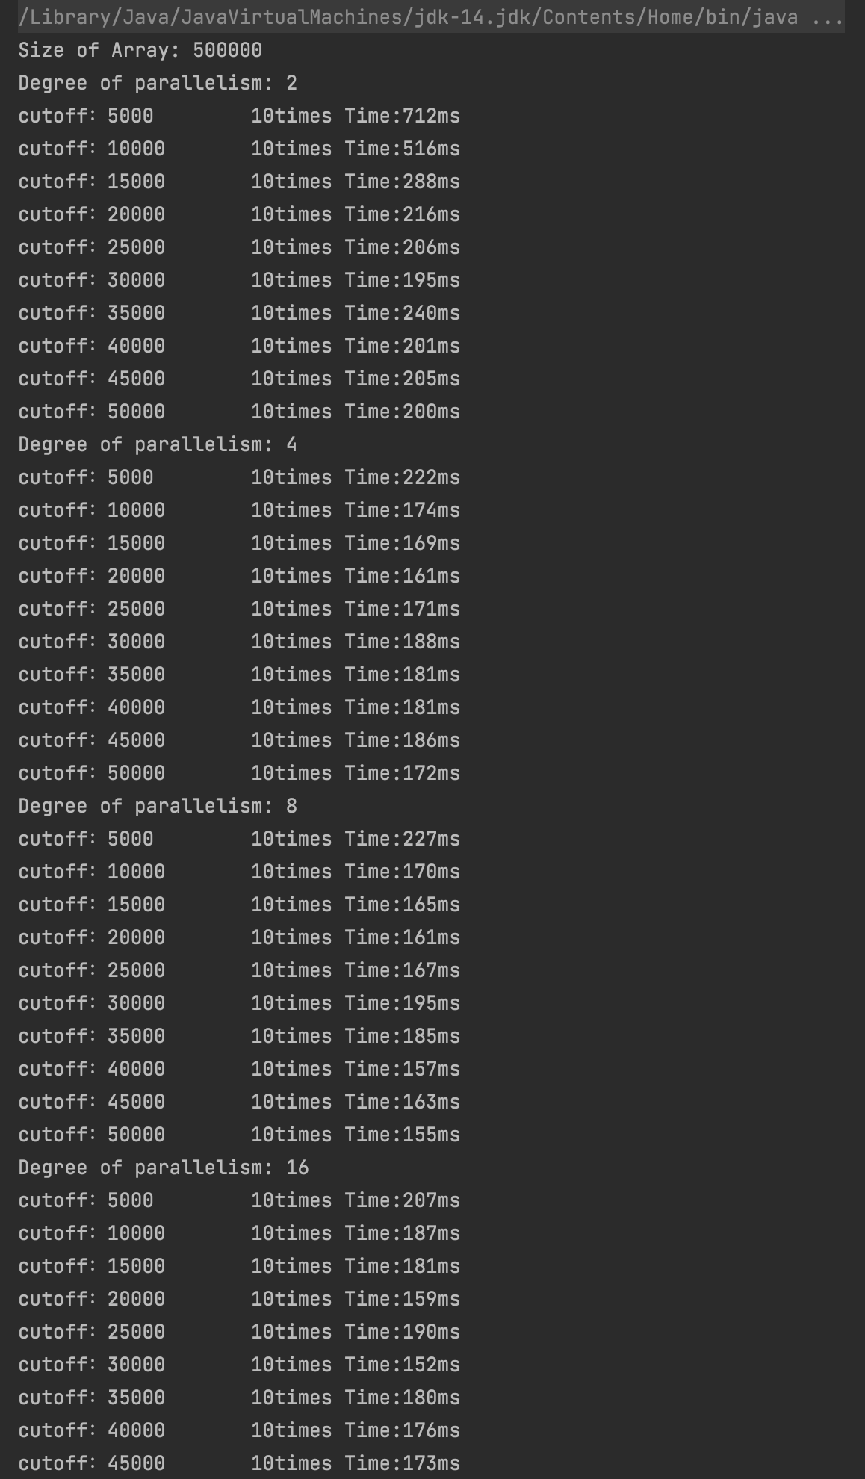

Size of Array: 50000

Degree of parallelism: 2

cutoff：5000 10times Time:712ms

cutoff：10000 10times Time:516ms

cutoff：15000 10times Time:288ms

cutoff：20000 10times Time:216ms

cutoff：25000 10times Time:206ms

cutoff：30000 10times Time:195ms

cutoff：35000 10times Time:240ms

cutoff：40000 10times Time:201ms

cutoff：45000 10times Time:205ms

cutoff：50000 10times Time:200ms

Degree of parallelism: 4

cutoff：5000 10times Time:222ms

cutoff：10000 10times Time:174ms

cutoff：15000 10times Time:169ms

cutoff：20000 10times Time:161ms

cutoff：25000 10times Time:171ms

cutoff：30000 10times Time:188ms

cutoff：35000 10times Time:181ms

cutoff：40000 10times Time:181ms

cutoff：45000 10times Time:186ms

cutoff：50000 10times Time:172ms

Degree of parallelism: 8

cutoff：5000 10times Time:227ms

cutoff：10000 10times Time:170ms

cutoff：15000 10times Time:165ms

cutoff：20000 10times Time:161ms

cutoff：25000 10times Time:167ms

cutoff：30000 10times Time:195ms

cutoff：35000 10times Time:185ms

cutoff：40000 10times Time:157ms

cutoff：45000 10times Time:163ms

cutoff：50000 10times Time:155ms

Degree of parallelism: 16

cutoff：5000 10times Time:207ms

cutoff：10000 10times Time:187ms

cutoff：15000 10times Time:181ms

cutoff：20000 10times Time:159ms

cutoff：25000 10times Time:190ms

cutoff：30000 10times Time:152ms

cutoff：35000 10times Time:180ms

cutoff：40000 10times Time:176ms

cutoff：45000 10times Time:173ms

cutoff：50000 10times Time:157ms

Degree of parallelism: 32

cutoff：5000 10times Time:197ms

cutoff：10000 10times Time:154ms

cutoff：15000 10times Time:163ms

cutoff：20000 10times Time:177ms

cutoff：25000 10times Time:186ms

cutoff：30000 10times Time:171ms

cutoff：35000 10times Time:172ms

cutoff：40000 10times Time:157ms

cutoff：45000 10times Time:163ms

cutoff：50000 10times Time:158ms

Degree of parallelism: 64

cutoff：5000 10times Time:202ms

cutoff：10000 10times Time:155ms

cutoff：15000 10times Time:197ms

cutoff：20000 10times Time:212ms

cutoff：25000 10times Time:254ms

cutoff：30000 10times Time:236ms

cutoff：35000 10times Time:168ms

cutoff：40000 10times Time:181ms

cutoff：45000 10times Time:170ms

cutoff：50000 10times Time:196ms

Process finished with exit code 0

Size of Array: 100000

Degree of parallelism: 2

cutoff：5000 10times Time:854ms

cutoff：10000 10times Time:686ms

cutoff：15000 10times Time:413ms

cutoff：20000 10times Time:406ms

cutoff：25000 10times Time:385ms

cutoff：30000 10times Time:458ms

cutoff：35000 10times Time:481ms

cutoff：40000 10times Time:414ms

cutoff：45000 10times Time:373ms

cutoff：50000 10times Time:363ms

Degree of parallelism: 4

cutoff：5000 10times Time:600ms

cutoff：10000 10times Time:460ms

cutoff：15000 10times Time:615ms

cutoff：20000 10times Time:503ms

cutoff：25000 10times Time:474ms

cutoff：30000 10times Time:470ms

cutoff：35000 10times Time:449ms

cutoff：40000 10times Time:498ms

cutoff：45000 10times Time:507ms

cutoff：50000 10times Time:488ms

Degree of parallelism: 8

cutoff：5000 10times Time:586ms

cutoff：10000 10times Time:434ms

cutoff：15000 10times Time:479ms

cutoff：20000 10times Time:503ms

cutoff：25000 10times Time:656ms

cutoff：30000 10times Time:602ms

cutoff：35000 10times Time:504ms

cutoff：40000 10times Time:574ms

cutoff：45000 10times Time:389ms

cutoff：50000 10times Time:436ms

Degree of parallelism: 16

cutoff：5000 10times Time:496ms

cutoff：10000 10times Time:508ms

cutoff：15000 10times Time:474ms

cutoff：20000 10times Time:571ms

cutoff：25000 10times Time:563ms

cutoff：30000 10times Time:515ms

cutoff：35000 10times Time:511ms

cutoff：40000 10times Time:405ms

cutoff：45000 10times Time:390ms

cutoff：50000 10times Time:412ms

Degree of parallelism: 32

cutoff：5000 10times Time:524ms

cutoff：10000 10times Time:380ms

cutoff：15000 10times Time:384ms

cutoff：20000 10times Time:371ms

cutoff：25000 10times Time:404ms

cutoff：30000 10times Time:382ms

cutoff：35000 10times Time:417ms

cutoff：40000 10times Time:355ms

cutoff：45000 10times Time:363ms

cutoff：50000 10times Time:392ms

Degree of parallelism: 64

cutoff：5000 10times Time:417ms

cutoff：10000 10times Time:388ms

cutoff：15000 10times Time:389ms

cutoff：20000 10times Time:444ms

cutoff：25000 10times Time:432ms

cutoff：30000 10times Time:417ms

cutoff：35000 10times Time:403ms

cutoff：40000 10times Time:368ms

cutoff：45000 10times Time:400ms

cutoff：50000 10times Time:357ms

Process finished with exit code 0

Size of Array: 200000

Degree of parallelism: 2

cutoff：5000 10times Time:1708ms

cutoff：10000 10times Time:1551ms

cutoff：15000 10times Time:928ms

cutoff：20000 10times Time:885ms

cutoff：25000 10times Time:929ms

cutoff：30000 10times Time:962ms

cutoff：35000 10times Time:931ms

cutoff：40000 10times Time:942ms

cutoff：45000 10times Time:911ms

cutoff：50000 10times Time:965ms

Degree of parallelism: 4

cutoff：5000 10times Time:1065ms

cutoff：10000 10times Time:851ms

cutoff：15000 10times Time:936ms

cutoff：20000 10times Time:936ms

cutoff：25000 10times Time:1004ms

cutoff：30000 10times Time:970ms

cutoff：35000 10times Time:1067ms

cutoff：40000 10times Time:1007ms

cutoff：45000 10times Time:1012ms

cutoff：50000 10times Time:937ms

Degree of parallelism: 8

cutoff：5000 10times Time:1029ms

cutoff：10000 10times Time:802ms

cutoff：15000 10times Time:814ms

cutoff：20000 10times Time:807ms

cutoff：25000 10times Time:767ms

cutoff：30000 10times Time:811ms

cutoff：35000 10times Time:711ms

cutoff：40000 10times Time:758ms

cutoff：45000 10times Time:768ms

cutoff：50000 10times Time:759ms

Degree of parallelism: 16

cutoff：5000 10times Time:1006ms

cutoff：10000 10times Time:837ms

cutoff：15000 10times Time:846ms

cutoff：20000 10times Time:828ms

cutoff：25000 10times Time:810ms

cutoff：30000 10times Time:862ms

cutoff：35000 10times Time:740ms

cutoff：40000 10times Time:768ms

cutoff：45000 10times Time:789ms

cutoff：50000 10times Time:727ms

Degree of parallelism: 32

cutoff：5000 10times Time:932ms

cutoff：10000 10times Time:804ms

cutoff：15000 10times Time:841ms

cutoff：20000 10times Time:805ms

cutoff：25000 10times Time:836ms

cutoff：30000 10times Time:801ms

cutoff：35000 10times Time:764ms

cutoff：40000 10times Time:764ms

cutoff：45000 10times Time:790ms

cutoff：50000 10times Time:711ms

Degree of parallelism: 64

cutoff：5000 10times Time:883ms

cutoff：10000 10times Time:782ms

cutoff：15000 10times Time:783ms

cutoff：20000 10times Time:791ms

cutoff：25000 10times Time:874ms

cutoff：30000 10times Time:808ms

cutoff：35000 10times Time:706ms

cutoff：40000 10times Time:752ms

cutoff：45000 10times Time:818ms

cutoff：50000 10times Time:766ms

Process finished with exit code 0